17.73: 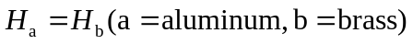
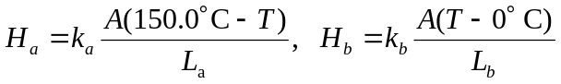

(It has been assumed that the two sections have the same cross-sectional area.)
